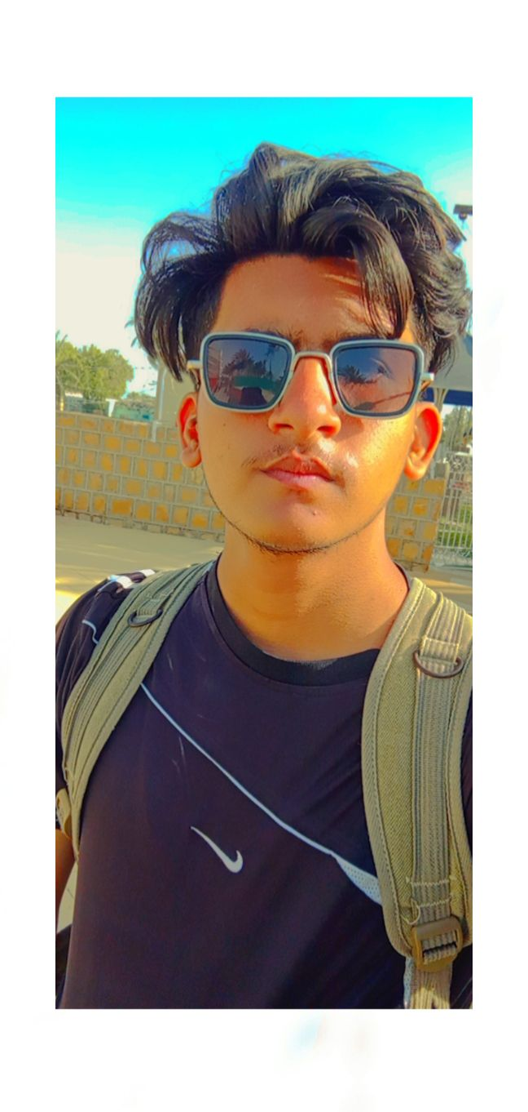

Summary

Front-End web Developer specializing in front end development Skilled with the development cycle for static web projects well versed in numerous technologies including HTML5, javaScript,CSS,Boostrap,Jquery,UI UX (knowledge), Git/Github.

Skill Highlights

|  |  |
| --- | --- |
| * HTML * CSS * UI/UX (knowledge) * XML * MS Office * Web Development | * Bootsrap * JQuery * Git/Github * JS * Figma/ui Desinging |

Experience

**Fresh Front-End Developer – Developed 9 pages of static Metric Conversion type website and worked on many more projects individually**

Education

Matriculation: Sidra Grammar High School – 2020

Certifications



Contact

**Address:**

Karachi,

Pakistan,

**Phone:**

03190695414

**Email:**

Hasnainalikhan039@gmail.com

**Github:** **https://github.com/Hasnain11222/new-hub**

Languages

English

Urdu

Syed Azbar Hasnain Ali